Title Page

Project Proposal:
An Evaluation of Algorithmic Bias and Fragility in Rate My Professor Sentiment Analysis Model

Danny D. Munoz and Daniel Nguyen
Texas A&M University - Central Texas
MATH-5389: AI Mathematics
Dr. Mienie Roberts
June 25, 2026

Table of Contents
Title Page 1
Table of Contents 2
List of Figures 3
List of Abbreviations 3
Concept 4
Scope 5
Group Membership 5
Changes on Lab 3 6
Mathematical Topics Used 6
1. TFIDF 6
2. LRC 7
Overfitting and Failures 9
References 11

List of Figures
Figure 2: Code block for TF-IDF using TdidfVectorizer library 7
Figure 3: Code block for LRC using LogisticRegression library 8
Figure 4: Training and testing result for the underfitting and overfitting models 9
Figure 5: Plotting result for the underfitting and overfitting models 9
Figure 6: Tricky reviews to bypass the model 10
Figure 7: Models’ analysis on tricky review cases 10
Figure 8: Bias analysis 10

List of Abbreviations
Abbreviation | Full Term
LRC | Logistic Regression Classifier
AI | Artificial Intelligence
NLP | Natural Language Processing
RMP | Rate My Professor
TF-IDF | Term Frequency-Inverse Document Frequency

An Evaluation of Algorithmic Bias and Fragility in Rate My Professor Sentiment Analysis Model

Concept
Rate My Professor is widely used by students to review instructors and choose courses, however, its ratings are highly emotional that reflect each student’s individual opinion and experience. Sentiment analysis gives us a neutral tool to classify reviews into positive or negative (Gong et al., 2022). One caveat is that these machine learning models can be fragile, prone to bias, sensitive to minor wording changes, and easy to be influenced by biases in the training data. Also, when professors have high academic standards, students often leave angry reviews, which causes the model to mix up tough grading with terrible teaching and label them as pure negativity. On the other hand, the site's reviews are filled with informal language, slang, sarcasm, and emotion; they offer an ideal dataset for studying how classical machine learning handles noisy, emotional text that will increase the complexity of NLP models.

Scope
The scope of this project includes training, testing, and evaluating baseline machine learning models on a pre-labeled dataset of RMP reviews. Deliverables include trained baseline models, a series of stress tests, and a final audit report. After initial training and evaluation, the project will stress-test models through overfitting experiments, adversarial examples, and bias test cases. These tests will determine whether strong accuracy is hiding underlying weaknesses, such as algorithmic fragility or harmful bias that could lead to false predictions. The audit report will document how the models succeed, where they fail, and why those failures matter in context. The project is intended for beginner machine learning and data analytics students, constraining the work to models built from scratch with a pre-labeled dataset.

Group Membership
Danny D. Munoz and Daniel Nguyen will collaborate on the project showcase, written components, artifact, design document, and evaluation report via shared documents and ongoing communication. Nguyen will serve as the primary content writer, while Munoz will handle revising and editing. The video walkthrough will be co-created, with Munoz handling 60-70% of the recorded demonstration, and Nguyen presenting the remainder.

Changes on Lab 3
In this revised version of the lab 2, typographical errors were corrected and unused citations removed from the reference list. The methodology also changed: the SVM model was excluded in favor of the TF-IDF vectorization with a Logistic Regression classifier. In this approach, the TF-IDF extracts numerical features from the text, which the Logistic Regression classifier uses to predict sentiment into three categories: "Awful," "Neutral," or "Great." The merge was chosen to maximize accuracy on the emotional-heavy dataset, while dropping the SVM model due to its complex architecture, which would have made it difficult to fully build and submit before the deadline.

Mathematical Topics Used

TFIDF
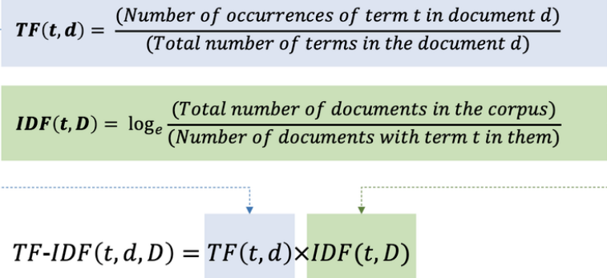
Prior to feeding text into a classifier the words must be converted to numbers. TF-IDF measures how important a word is to a specific review within the entire dataset (Lu, 2025).

Figure 1: TF-IDF (Hashim et al., 2023)
For the sublinear term frequency, when sublinear_tf=True is used, the importance of a word is based on a logarithmic scale instead of its raw count, which means that even if the words are repeated many times, it does not increase its importance by very much. 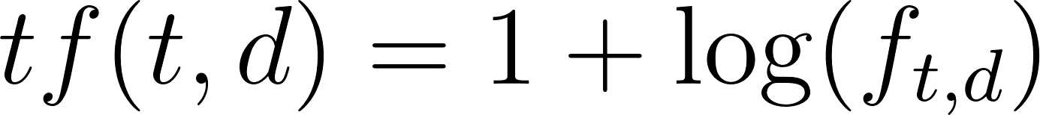 where 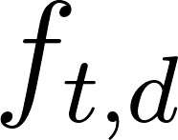 is the raw count of term t in document d, and 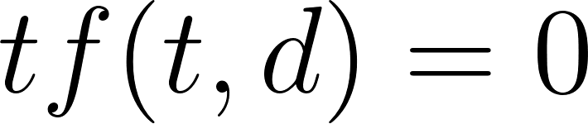 if 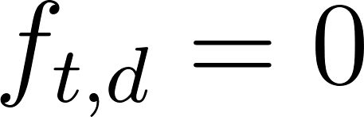 . For the inverse document frequency part, it measures how unique or informative a word is across all documents with words that appear in many documents receiving a lower score, while words that appear in only a few documents receive a higher score. Scikit-learn is used to prevent the zero division errors 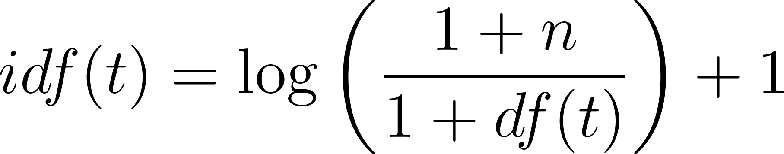, where n is the total number of documents and 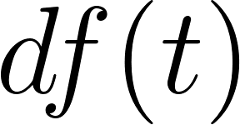 is the number of documents containing term t. The formula is derived from the standard formula for idf: 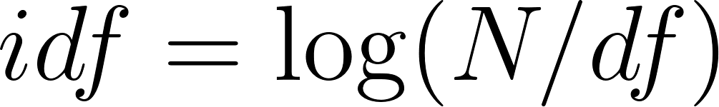, but adding 1 will prevent the division-by-zero errors when the model see new vocabularies. There is also a use of norm="l2", which makes sure that each document vector is scaled so that its total length is 1. It has to be standardized because longer documents do not automatically receive larger values.
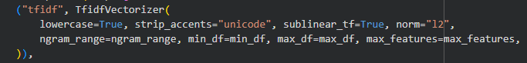Figure 2: Code block for TF-IDF using TdidfVectorizer library

LRC
The classifier calculates the probability that a review belongs to each of the following classes: "Awful", "Neutral", "Great", and then assigns the review to the class that has the highest possibility. The probability is calculated through this equation, where  represents the weight vector for class k.
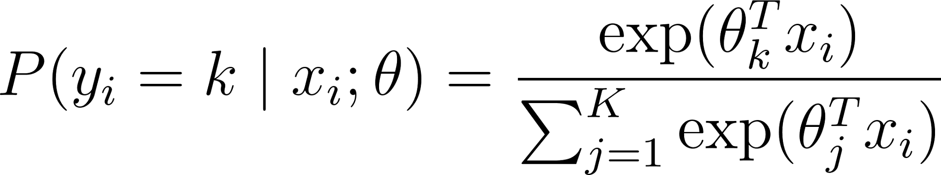
After that, the model learns by reducing prediction errors and preventing the weights from becoming too large, all by the help of the C parameter that controls to reduce overfitting. A smaller C gives stronger regularization, and vice versa. Different values of C from 0.1, 1.0, 100.0, and 1000.0 are tested to find the model with the best performance. Also, the algorithm minimises the loss function by penalizing the L2 norm of the weights.
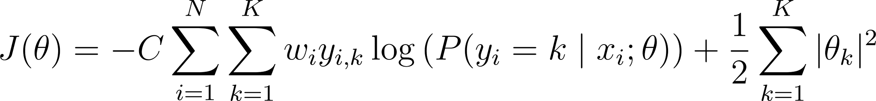
With class_weight="balanced" , the model gives more importance to reviews from classes with fewer samples to allow it to learn fairly from imbalanced datasets instead of favoring the majority class. The sample weight  in the function is inversely proportional to class frequencies. Lastly, there is a solver called SAGA that is a variant of the stochastic average gradient descent. With the solver, we do not need to build a program to optimize or calculate the softmax probability. Scikit-learn will automatically calculate and optimize through the .fit(X_train, y_train) method that trains the Logistic Regression model and the .predict(X_test) method is used to assign each test sample to the class with the highest predicted probability.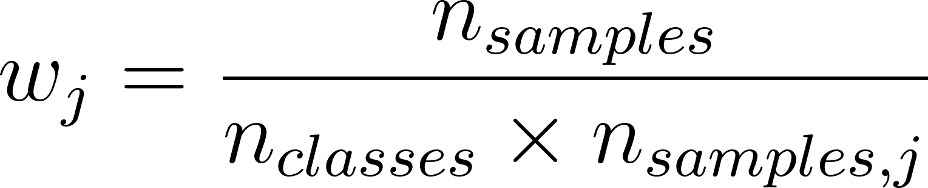
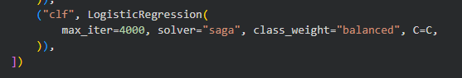
Figure 3: Code block for LRC using LogisticRegression library

Overfitting and Failures
After the training, we deregularized the model to force it to memorize the dataset rather than learn general patterns. The initial model used a minimum document frequency and a regularization parameter C of 1, but we pushed it to extreme overfitting by expanding 4-grams, lowering minimum document frequency to 1 (forcing token memorization), and increase C to 1000 (allowing extreme weights on rare tokens).
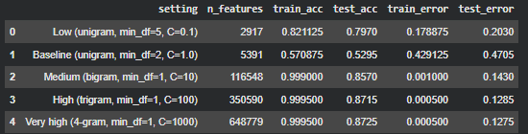

Figure 4: Training and testing result for the underfitting and overfitting models
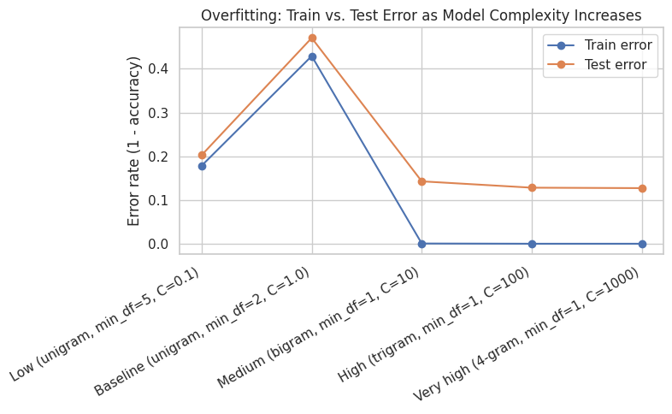

Figure 5: Plotting result for the underfitting and overfitting models

Since the model only counts words rather than understanding context, it fails on tricky language like sarcasm. The overfit model sees positive words in an ironic review and wrongly predicts that it is "Great." Similarly misreads reviews with many nice words but a negative overall meaning as positive. Simple negations also confuse it; "not a bad professor" gets marked as "Awful" because it contains "bad."
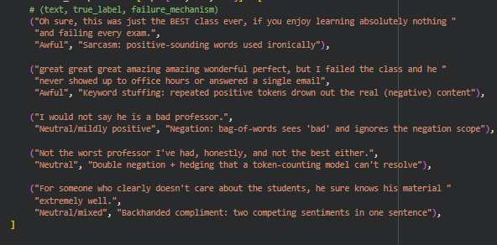

Figure 6: Tricky reviews to bypass the model
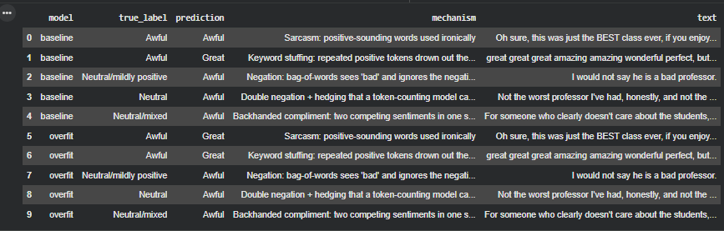

Figure 7: Models’ analysis on tricky review cases

The model also performs worse on reviews mentioning accents or language: 47 matching reviews, accuracy dropped to 0.5957 versus 0.7563 on the rest of the data, with a higher "Awful" prediction rate ( 0.4681 vs. 0.3574).
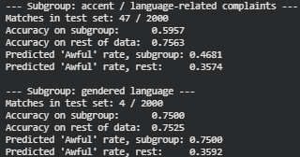

Figure 8: Bias analysis

References
Gong, X., Ying, W., Zhong, S., & Gong, S. (2022). Text Sentiment Analysis Based on Transformer and Augmentation. Frontiers in Psychology, 13. https://www.frontiersin.org/journals/psychology/articles/10.3389/fpsyg.2022.906061/full
Hashim, A., Mohammad-Reza Feizi-Derakhshi, & Pedram Salehpour. (2023). Enhancing Fake News Detection by Multi-Feature Classification. IEEE Access, 11, 139601–139613. https://doi.org/10.1109/access.2023.3339621
Lu, J. (2025). Text vectorization in sentiment analysis: A comparative study of TF-IDF and Word2Vec from Amazon Fine Food Reviews ITM Web of Conferences, 70, 03001. https://www.itm-conferences.org/articles/itmconf/pdf/2025/01/itmconf_dai2024_03001.pdf

